LOAN ORIGINATOR MEMO · SHORT FORM
Mogo IFN (Romania): how likely is it to fail to pay its debts?
This memo answers one question: what is the chance that Mogo IFN S.A. — the company Mintos investors lend to — fails to pay its lenders in the next 12 months, and why. Written 20 September 2026 from the audited accounts for 2022–24, unaudited December 2025 management accounts, Eleving Group's 2025 report and Mintos data of 13 September 2026. The full analysis is in the long memo (link at the end).
THIS IS NOT FINANCIAL ADVICE
This memo was prepared with the help of AI from publicly available documents. It is general information for education only. It is not investment advice, not a recommendation to buy, sell or hold any loan, note or security, and does not take account of your personal circumstances. Figures, calculations and conclusions may contain errors — verify them against the original filings before acting. Investing through P2P platforms can result in the loss of all money invested. If in doubt, consult a licensed financial adviser.

The answer: about 1 in 18 — C, Watch. Sound business, weak country, one governance flag
AI score (all risks together) | Financial strength | Loan book | Country: Romania | Group and other risks
52 / 100  About 1 in 18 (5.5%) chance of failing to pay in the next year — C, Watch. Framework limit 6% of a portfolio; Romania's 5% binds. With Eleving's support: about 1 in 25 (4%). | 60 · C  Based on the financial reports alone: about 1 in 26 (3.8%). Covers its interest 2.3× before bad debts and keeps €13 of every €100 in a normal year. | 40 · D  If the current trend continues: about 1 in 8 (12.5%). Loans over 60 days late rose from 10.9% to 13.5% while the book grew 35% and turned unsecured. | 40 · D  From the country alone: about 1 in 8 (12.5%). No government since May 2026, a cap on the cost of credit, falling real wages. | 53 · C  Other risks alone: about 1 in 19 (5.1%). Eleving (Fitch B) has €27m ranking behind investors — but a €3m tax dispute, a cap-compliance question, a €275m bond guarantee and one veto flag.

One veto flag — read before the numbers
At end-2024 Mogo IFN had lent €7.8m to sister companies — more than its €6.6m of equity. Under our rules that puts the company on its own in the Avoid band (at least 1 in 4) until audited accounts show the money back. The unaudited December 2025 accounts show it repaid; the 2025 audit decides. The scores above are on the numbers, ignoring the flag.

Odds are one-year chances of failing to pay, set from a 0–100 score anchored to S&P default rates; each sub-score shows the odds as if it were the only risk — method at the end.
At a glance: a licensed Romanian lender, €63m book, now mostly unsecured instalment loans, part of Eleving
What it is | Where it lends | Products and rates | How big | Who owns it | Since
Non-bank lender (IFN) on the National Bank of Romania's Special Register — the tier with tighter supervision | Romania only | Car loans (RON 5,000–60,000, 6–60 months) until 2024; unsecured instalment loans since 2025, now 9/10 of the book. Charges about 37–44% a year; Romania caps larger loans at 34.5% | €52m gross book end-2024 (+35%); €63m December 2025 (+21%); 64 staff; €18m income in 2024 | Eleving Group (Latvia), 99.99% through AS Eleving Stella; Fitch B, outlook positive; 18 countries | 2016; Special Register 2018

Where to lend to it | Outstanding | Rate offered | Currency | Buyback | Parent support | Mintos Risk Score
Mintos (Notes) | €6.4m | 10.13% average | EUR and RON | Yes | Letter of Comfort (2017); Eleving's 2025 accounts mention guarantee agreements for 'certain subsidiaries' — which ones is not stated; €27m of Eleving loans rank behind Mintos | 9.0 / 10 (July 2026)
Mintos investors are paid 10% to lend to a company that charges its borrowers about 40% and pays its parent 12.25% — and the parent's money ranks behind theirs. Mintos data of 13 September 2026, not independently verified.
1. Financial strength: earns enough in a normal year — the 2024 loss was a one-off tax bill (about 1 in 26)
Of every €100 it earns, interest and bad debts take €53; running the business €33; €13 is left. Income could fall 13% before it could no longer cover its interest.
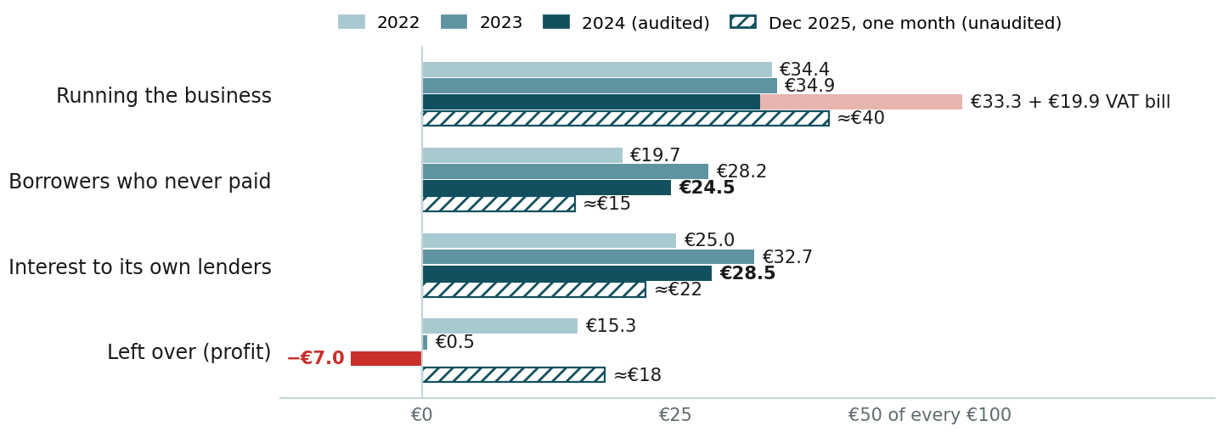
Conclusion: profitable in 2022, thin in 2023 when bad debts jumped, a reported €1.2m loss in 2024 only because a RON 15m (€3m) VAT assessment for 2017–22 was paid and provided (under appeal); without it 2024 made €1.5m. Income grew 29% in 2024 and, on the December 2025 management accounts, the new instalment business keeps about €18 of every €100 — about €5m of profit for the year, unaudited.
Balance sheet: two cushions stand in front of Mintos — €6.6m of equity (12% of assets; 18% by December 2025) and €27.2m of Eleving's own money that is paid after all other lenders. The weak point: €7.8m lent to sister companies at end-2024, more than the equity.
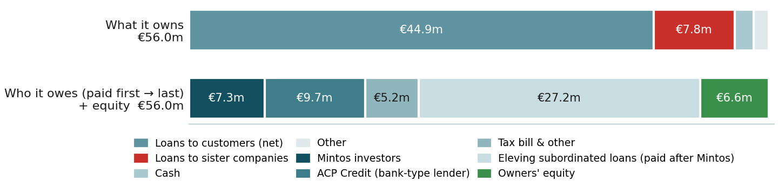
Conclusion: outside lenders (Mintos €7.3m, ACP Credit €9.7m) have about 60% of the balance sheet standing behind them — unusually strong for a lender of this size. No dividends have been paid; Eleving converted €6m of loans into shares in 2024. Debt due within 12 months was €1.6m at end-2024; the Mintos line matured in September 2026 and is being rolled. About €38m of borrowings are in euros against a lei loan book — a 10% fall in the leu would cut profit by about a third.
2. Loan book: getting worse — defaults up from 10.9% to 13.5% while the book grew 35% and went unsecured (about 1 in 8)
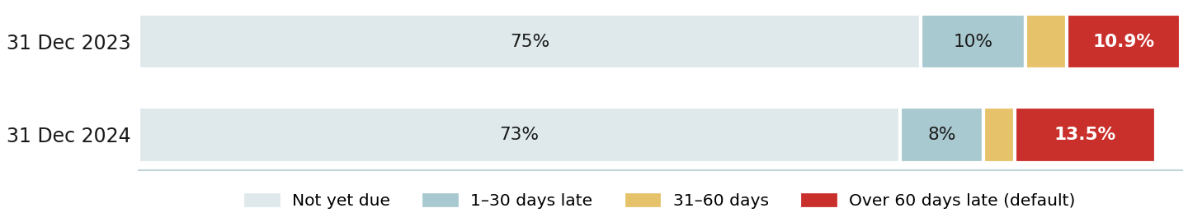
Conclusion: 13.5% of the book was more than 60 days late at end-2024 (the company's default definition), against a Romanian consumer-IFN average of 8.7%; in euros defaults rose two-thirds in a year. The book is fully provided — allowances of 13.6% cover the defaulted loans in full — and defaulted loans are sold to collectors at a small gain, so the loss sits in the allowance rather than in write-offs. Since 2025 nine-tenths of the book is unsecured instalment lending, with an allowance of 10% at December 2025 (unaudited): either the new loans are better, or too new to have gone bad. Bad debts could rise by half and it would still cover its interest — at a loss of about €0.7m.
3. Country: Romania is the biggest single risk — D, High (about 1 in 8)
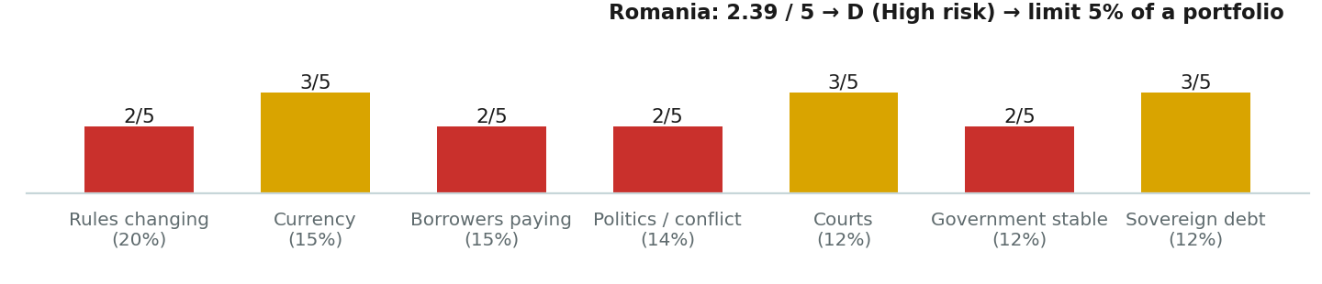
Conclusion: no government since 5 May 2026 and early elections discussed; a sovereign rating one notch above junk with a negative outlook at all three agencies; output below a year ago, real wages down 2.5%, youth unemployment 31%; a November 2024 law capping the cost of larger consumer loans at 34.5% — the loans Mogo IFN writes — and new EU consumer-credit rules by emergency ordinance from 20 November 2026 that take the enforceable title away from debt collectors. Our framework's limit for Romanian lenders is 5% of a portfolio. Full analysis: Romania country memo (link at the end).
4. Group and other risks: Eleving stands behind it with money, not a confirmed guarantee; a tax dispute and a cap question are open (about 1 in 19)
Risk | Status | What we found
Group support — Eleving Group (Fitch B, positive; our grade B) | Money in | €27.2m of subordinated loans at 12.25% due 2029–30, €6m converted to equity in 2024, €9.2m more lent by December 2025; a Letter of Comfort (2017) and guarantee agreements for 'certain subsidiaries' in Eleving's 2025 accounts (note 41) — not confirmed for Mogo IFN. Group odds about 1 in 33; with this support Mogo IFN's odds about 1 in 25.
Guarantee given for the group's debts | ● Warning | Joint and several guarantor of Eleving's €275m 9.5% bonds due October 2030. If Eleving defaulted (its own odds about 3 in 100), Mogo IFN would be liable for far more than it owns.
Money lent to sister companies | Veto flag | €7.8m at end-2024 — 119% of equity, above the 50% veto line in every audited year; repaid to nil by December 2025 on the management accounts. Management fee and recharges to Eleving Stella €2.3m in 2024, 13% of income.
Tax dispute | ● Watch | RON 15.1m (€3.0m) VAT assessed for 2017–22, paid 15 January 2025, under appeal; RON 2.6m provided for 2023–24. If the appeal fails nothing more is due; if the tax office applies the same view to 2023–24, a further €0.5m — already provided (RON 2.6m).
Regulatory compliance | ● Watch | The 2024 accounts say signing several contracts with one customer on the same day 'could face regulatory implications' under the cost-of-credit cap; underwriting changed from April 2025. No sanction found; the central bank does not routinely publish fines against named IFNs.
Trust in the numbers | ● Watch | Full IFRS accounts in lei with detailed notes and candid disclosure — but the auditor's reports and name are not in the document set (Eleving's bond prospectus describes the 2024 figures as audited), and the 2025 figures are one month of management accounts.
Payments, management, fraud | ● OK | No late payment to any lender found; the same CEO and deputy signed the 2023 and 2024 accounts; no adverse press or consumer-authority finding found for 2025–26.
What would change the answer
Better | Worse | Check again
2025 audited accounts with a clean opinion and no loans to sister companies — lifts the veto flag. Defaults back under 10% through 2026 and the tax appeal and the cap-compliance question closed — B (about 1 in 33). A confirmed guarantee from Eleving — odds move to the group's, about 1 in 33. | Defaults on the new instalment book above the car book's; a regulatory finding on same-day contracts or pricing above the cap; new lending to sister companies; the leu sliding with €38m of euro debt unhedged; Romania moving to E; Eleving's grade falling below B. | When the 2025 audited accounts appear (overdue at the trade register since May 2026); after 20 November 2026 (new consumer-credit rules); when the tax appeal is decided; after any Romanian rating action; after each Mintos Risk Score update.
How the odds are set
Six questions are scored 1–5 and weighted — earns enough 30%, loan book 20%, safety cushion 20%, country 15%, trust in the numbers 10%, warning signals 5% — into a 0–100 score. The score becomes one-year odds on a curve anchored to S&P's long-run default rates: 80 ≈ BB ≈ 1 in 100; 65 ≈ B ≈ 1 in 33; 50 ≈ B− ≈ 1 in 17; 35 ≈ CCC ≈ 1 in 6. Financial strength = earnings and cushion; loan book = the book question; country = the country grade; group and other = trust and warning signals. Each sub-score shows the odds as if that were the only risk. A confirmed guarantee from a rated parent brings the odds to the parent's; written support plus money already put in behind investors takes them halfway; words alone change nothing; a veto (loans to related parties above half the cushion, a qualified opinion or going-concern doubt, a covenant breach, delayed investor payments, owners taking out more than earned two years running) sets the standalone odds to at least 1 in 4. Small frontier lenders do worse than the average rated company, so read every figure as a floor. Limits: A 20%, B 12%, C 6%, D 2%, E 0% of a portfolio; a subsidiary counts inside its group's and its country's limit.
Documents and sources
Mogo IFN S.A. financial statements 2023 (with 2022 comparatives) and 2024 — IFRS, in lei; the auditor's reports listed in the contents are not attached (Mintos LO document set 98A9C12C, 3873535C) · Mogo IFN management accounts, December 2025, one month, in euros, unaudited (34C051CB) · Eleving Group bond prospectus of 29 September 2025 (guarantor list), integrated annual report 2025 (note 41, audited by BDO), 12M 2025 and 6M 2026 results, Fitch rating action June 2025 · Mintos lending-company pages (Overview, Risk Score, Loans performance), 9 July and 13 September 2026 · Romania country memo, Eleving group memo and Mogo IFN long memo (this series, 13 September 2026) · Exchange rates: RON 4.9315 / 4.9465 / 4.9746 per euro (2022–24 averages), 4.9474 / 4.9746 / 4.9741 (year-ends), ECB.

Not found: who audits Mogo IFN and whether the opinions are clean; the outcome of the VAT appeal; any regulator action on the same-day contracts; the full-year 2025 audited result; whether the euro borrowings are hedged.
Full analysis — Mogo IFN long memo (this series): MogoIFN_memo_2026-09-13.pdf
Romania country memo: Romania_country_memo_2026-09-13.pdf
Eleving Group memo: Eleving_group_memo_2026-09-13.pdf
Eleving Group bond prospectus, 29 September 2025 (guarantors): lb.lt
Eleving Group 12M 2025 results and integrated annual report: eleving.com
National Bank of Romania — IFN registers: bnr.ro
Mintos lending companies (public pages): mintos.com
Company site: mogo.ro

This memo was prepared with the help of AI from the public documents listed above. It may contain errors of extraction, calculation or interpretation. Readers should verify figures against the original filings and form their own view. The percentages are how our framework expresses risk on a common scale; they are not advice for any particular investor.
THIS IS NOT FINANCIAL ADVICE
This memo was prepared with the help of AI from publicly available documents. It is general information for education only. It is not investment advice, not a recommendation to buy, sell or hold any loan, note or security, and does not take account of your personal circumstances. Figures, calculations and conclusions may contain errors — verify them against the original filings before acting. Investing through P2P platforms can result in the loss of all money invested. If in doubt, consult a licensed financial adviser.

